Consent to Examination

By filling out the proceeding information, you are granting Physio F/X voluntary consent to perform all procedures deemed appropriate to assess and treat your current area of complaint. All information obtained during this process will remain strictly confidential; and the details of your case will be limited to only those parties directly responsible for your care.

Section 1 – Personal Information
Male Female
First Name: ____________________________Last Name_____________________________
Address: ______________________________ Home Tel: ( ) ______-___________
City: __________________________________ Mobile Tel: ( ) ______-___________
Postal Code: _______ - _______ Work Tel: ( ) _______-__________
May we contact you at work? Yes No
Date of Birth: _____ /_____ /________ E-Mail ____________________________
day month year
Emergency Contact Name: # _Relation: -

Section 2 – General Health Information
Doctor’s Name: ___________________________________________ May we contact your Doctor?
€ Yes € No
Phone Number: ___________________________________________
Office Address: ___________________________________________
___________________________________________
€ Walk-In Physician € Family Physician € Specialist ____________________

Is your injury the result of a motor vehicle accident (MVA)? YES NO
Is your injury the result of a work place accident (WSIB)? YES NO

Date of Accident: claim #:

Section 3 - Health History

Have you ever been to a Chiropractor or Physiotherapist before? YES NO
When was your last appointment? (approx.) __________________
Were X-rays taken? YES NO
Do you have any of the following: (Please check all that apply)
Diabetes High Cholesterol
High Blood Pressure History of Cancer
History of Heart Disease Night Pain
Osteoporosis Unrelenting Pain
Incontinence Unexplained Weight Loss (>5 lbs)
Recent Infection Age > 55 years old
Recent Trauma Smoker ___ pack____years
Past Surgery Sleep Apnea
Rheumatoid Arthritis (other auto immune disorders)
Prolonged Use of Steroids, Corticosteroids, or Prednisone
Osteo Arthritis:
Asthma/Allergies: PAGE OVER ►►►

In the diagram provided below, please mark the areas on your body that you feel best represent the pain(s) or sensations(s) you are currently experiencing. Please number all areas according to priority.
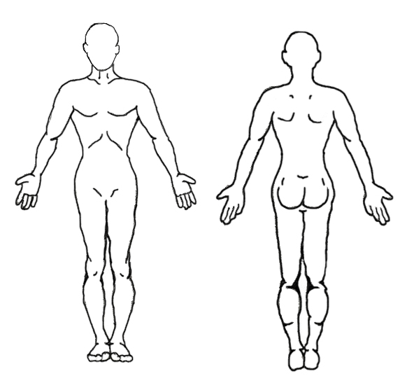
Symbols:
- Pain wmwmw
- Pins & ●●●●
Needles 
- Numbness ooooo
- Burning 
- Sharp or 
Stabbing
- Dull Ache XXXXX
- Stiff &
Tight

FRONT BACK
How severe are your symptoms now? Please place a vertical mark along the line below to indicate how strongly you feel symptoms at this moment. Please identify which symptom you are rating with its number (if more than one)

No Pain Worst Pain Imaginable

0 100
Do you have any of the following complaints, in addition to those indicated above?

- Asthma
- Allergies
- Constipation
- Painful Menstruation
- Dizziness
- Fatigue/Weakness
- Problems Sleeping
- Back Ache
- Headache
- Stiff Neck
- Jaw Pain
- Shoulder Pain
- Elbow Pain
- Wrist Pain
- Back Pain
- Hip Pain
- Knee Pain
- Foot Pain
- Muscle Pain
- Arthritis
- Rheumatoid Arthritis
- Prescription Medication
Please List: __________________ ______________________________________________________________________________________________________________________________________________________________________________

Have you been diagnosed with a medical disease/illness/condition? List diagnosis and date (yr).

Please indicate any past surgery, and/or any diagnostic procedures you have had with the approximate date ( yr).

Google to Yellow Pages | Google to Website | Referral: whom may we thank?
Yahoo to Yellow Pages | Yahoo to Website | Magazine: (name)
Yellow Pages phonebook | Building sign | Other:
Please take a moment to let us know how you heard about us by selecting an option below:

